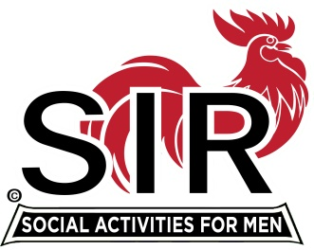
Las Trampas Branch 116
BEC Meeting Agenda
January 20, 2020, 9:30 AM
The Mission of SIR is to enhance the lives of our members through fun activities, events and luncheons – while making friends for life.

09:15 Coffee Available
09:30 Call to order; Secretary confirm a quorum
09:31 Secretary – Fred Schafer – Approval of November minutes
09:33 Treasurer – Jim Nickels/Alan Fitzgerald – Report, Missed Luncheon Receipts
09:37 Audit report 2019: Ron Armijo
09:47 Standing Reports
- Attendance – Jim Flessner/Mike Scheider – Attendance, Guests and Visitors
- Membership – Phil Goff – New Members to be inducted,
- RAMP Department Head Reports:
- Recruitment
- Activity Coordinator
- Member relations
- Publicity
10:10 Big SIR Report – Michael
- Contact info.
- Business Cards
- Branch goals 2020
10:20 Little SIR Report – Sam Beret
1. Speaker: CCC Historical Society
10:25 Old Business
- TBA
10:27 New Business:
- TBA
10:30 Other Discussion

10:35 Adjourn; Next BEC Meeting, February 17, 2020

